# Integrating Fuzzy Logic with Neural Networks: A Python Implementation for Advanced Machine Learning Applications

[[Everton Gomede, PhD](https://medium.com/@evertongomede?source=post_page-----b0f59d8466dd--------------------------------)](https://medium.com/@evertongomede?source=post_page-----b0f59d8466dd--------------------------------)

[[The Modern Scientist](https://medium.com/the-modern-scientist?source=post_page-----b0f59d8466dd--------------------------------)](https://medium.com/the-modern-scientist?source=post_page-----b0f59d8466dd--------------------------------)

[Everton Gomede, PhD](https://medium.com/@evertongomede?source=post_page-----b0f59d8466dd--------------------------------)

·

[Follow](https://medium.com/m/signin?actionUrl=https%3A%2F%2Fmedium.com%2F_%2Fsubscribe%2Fuser%2Fb1a64eb107f0&operation=register&redirect=https%3A%2F%2Fmedium.com%2Fthe-modern-scientist%2Fintegrating-fuzzy-logic-with-neural-networks-a-python-implementation-for-advanced-machine-learning-b0f59d8466dd&user=Everton+Gomede%2C+PhD&userId=b1a64eb107f0&source=post_page-b1a64eb107f0----b0f59d8466dd---------------------post_header-----------)

Published in

[The Modern Scientist](https://medium.com/the-modern-scientist?source=post_page-----b0f59d8466dd--------------------------------)

·

5 min read

·

5 days ago

12

# Introduction

Fuzzy neural networks represent an innovative blend of fuzzy logic and neural networks, offering a powerful approach to handle complex, non-linear problems that are hard to model with traditional techniques. This essay will delve into the concept, functionality, and applications of fuzzy neural networks, exploring their significance in the realm of artificial intelligence and machine learning.

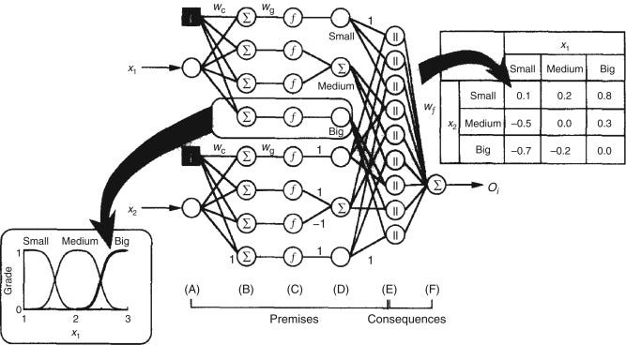

*Where precision meets intuition: blending the clarity of neural networks with the wisdom of fuzzy logic.*

# Understanding Fuzzy Neural Networks

## Conceptual Foundation

Fuzzy neural networks are a synergy of two distinct yet complementary technologies: fuzzy logic and neural networks. Fuzzy logic, introduced by Lotfi Zadeh in the 1960s, extends traditional binary logic to handle the concept of partial truth, where values range between completely true and completely false. This approach is particularly effective in dealing with imprecise, ambiguous, or subjective information. Neural networks, on the other hand, are inspired by the structure and function of the human brain, designed to recognize patterns and learn from empirical data.

## Integration of Fuzzy Logic and Neural Networks

The integration of fuzzy logic into neural networks brings the advantage of handling uncertain, noisy, or incomplete data, which is a common challenge in real-world scenarios. In a fuzzy neural network, the learning process is guided not only by numerical data but also by fuzzy rules and membership functions, which define the degree to which an element belongs to a certain set.

# Functionality and Architecture

## Learning and Adaptation

Fuzzy neural networks learn in a manner similar to traditional neural networks. They adjust their weights based on the input data and the associated fuzzy rules, improving their performance over time. This learning can be supervised, unsupervised, or reinforced, depending on the application.

## Architecture

The architecture of a fuzzy neural network typically consists of several layers: an input layer, one or more hidden layers, and an output layer. The input layer receives the raw data, which is then processed through the hidden layers using fuzzy logic operators. The output layer provides the final decision or prediction, often in a fuzzy format that is then defuzzified for practical use.

# Applications and Advantages

## Wide Range of Applications

Fuzzy neural networks have been successfully applied in various domains, including control systems, pattern recognition, decision-making, and predictive modeling. For instance, in automotive engineering, they are used for developing advanced driver-assistance systems (ADAS) that require handling uncertain and imprecise information.

## Advantages

One of the key advantages of fuzzy neural networks is their ability to model complex, nonlinear systems that are difficult to tackle with conventional methods. They are robust to noise and capable of dealing with ambiguity and uncertainty in the data, making them highly versatile and effective in diverse applications.

# Challenges and Future Directions

## Challenges

Despite their benefits, fuzzy neural networks face challenges such as determining the optimal number of rules, the risk of overfitting, and the computational complexity associated with training large networks.

## Future Directions

Ongoing research is focused on enhancing the efficiency, scalability, and interpretability of fuzzy neural networks. Efforts are also being made to integrate them with other emerging technologies, like deep learning and quantum computing, to further expand their capabilities.

# Code

Creating a complete Python implementation of a fuzzy neural network with a synthetic dataset and plots involves several steps. Below, I’ll provide a high-level overview and a basic implementation using Python libraries. For simplicity, we’ll create a synthetic dataset suitable for a regression task and use a basic fuzzy neural network architecture.

## Overview of Steps

1. Generate a Synthetic Dataset: We’ll create a synthetic dataset with features and targets.
2. Build a Fuzzy Neural Network Model: Implementing a fuzzy logic layer in a neural network.
3. Train the Model: Use the synthetic dataset to train the model.
4. Evaluate and Plot Results: Evaluate the model’s performance and plot the results.

## Python Implementation

We will use libraries like numpy for data manipulation, skfuzzy for fuzzy logic, and tensorflow or keras for neural networks. Ensure you have these libraries installed in your Python environment.

!pip install scikit-fuzzy

Creating a complete Python implementation of a fuzzy neural network with a synthetic dataset and plots involves several steps. Below, I’ll provide a high-level overview and a basic implementation using Python libraries. For simplicity, we’ll create a synthetic dataset suitable for a regression task and use a basic fuzzy neural network architecture.

# Overview of Steps

1. Generate a Synthetic Dataset: We’ll create a synthetic dataset with features and targets.
2. Build a Fuzzy Neural Network Model: Implementing a fuzzy logic layer in a neural network.
3. Train the Model: Use the synthetic dataset to train the model.
4. Evaluate and Plot Results: Evaluate the model’s performance and plot the results.

# Python Implementation

We will use libraries like numpy for data manipulation, skfuzzy for fuzzy logic, and tensorflow or keras for neural networks. Ensure you have these libraries installed in your Python environment.

!pip install scikit-fuzzy

import numpy as np  
import matplotlib.pyplot as plt  
import tensorflow as tf  
from tensorflow.keras.layers import Layer, Input, Dense  
from tensorflow.keras.models import Model  
  
# Generate synthetic data  
np.random.seed(0)  
X = np.random.uniform(-1, 1, (100, 2)) # 100 samples, 2 features  
y = X[:, 0]\*\*2 + X[:, 1]\*\*2 + np.random.normal(0, 0.1, 100) # Quadratic function with noise  
  
# Split the data into training and testing sets  
train\_size = int(len(X) \* 0.8)  
X\_train, X\_test = X[:train\_size], X[train\_size:]  
y\_train, y\_test = y[:train\_size], y[train\_size:]  
  
# Custom Fuzzy Layer  
class FuzzyLayer(Layer):  
 def \_\_init\_\_(self, output\_dim, \*\*kwargs):  
 super(FuzzyLayer, self).\_\_init\_\_(\*\*kwargs)  
 self.output\_dim = output\_dim  
  
 def build(self, input\_shape):  
 self.kernel = self.add\_weight(name='kernel',   
 shape=(input\_shape[1], self.output\_dim),  
 initializer='uniform',  
 trainable=True)  
  
 def call(self, x):  
 return tf.math.sigmoid(tf.matmul(x, self.kernel))  
  
# Neural Network Model  
input\_layer = Input(shape=(2,))  
fuzzy\_layer = FuzzyLayer(10)(input\_layer)  
hidden\_layer = Dense(10, activation='relu')(fuzzy\_layer)  
output\_layer = Dense(1)(hidden\_layer)  
  
model = Model(inputs=input\_layer, outputs=output\_layer)  
model.compile(optimizer='adam', loss='mean\_squared\_error')  
  
# Train the model  
model.fit(X\_train, y\_train, epochs=100, batch\_size=10, verbose=1)  
  
# Evaluate the model  
predictions = model.predict(X\_test)  
mse = np.mean((y\_test - predictions.flatten())\*\*2)  
print("Mean Squared Error:", mse)  
  
# Plotting results  
plt.scatter(X\_test[:,0], y\_test, label='True')  
plt.scatter(X\_test[:,0], predictions, label='Predicted')  
plt.legend()  
plt.title("Fuzzy Neural Network Predictions")  
plt.show()

Mean Squared Error: 0.13899372739258858

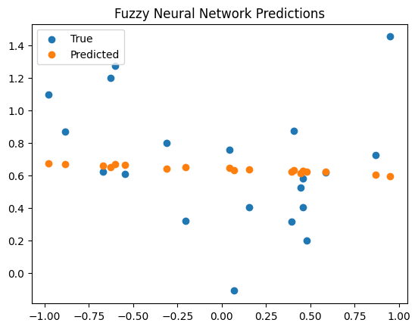

## Notes

* This code provides a basic framework and may require adjustments based on specific requirements.
* The fuzzy logic part is simplistic and illustrative. In practice, the design of fuzzy systems can be much more complex.
* Depending on your exact needs, the architecture of the neural network and the design of the fuzzy system might need significant modifications.
* Ensure that all necessary packages (numpy, matplotlib, skfuzzy, tensorflow) are installed in your Python environment before running this code.

# Conclusion

Fuzzy neural networks represent a significant advancement in the field of artificial intelligence, offering a robust framework for dealing with complex, uncertain systems. By combining the strengths of fuzzy logic and neural networks, they provide a flexible and powerful tool for a wide range of applications. As research continues to evolve, we can expect to see even more innovative uses and enhancements of this technology, solidifying its role in the future of AI and machine learning.

## [skfuzzy 0.2 docs - skfuzzy v0.2 docs](https://pythonhosted.org/scikit-fuzzy/?source=post_page-----b0f59d8466dd--------------------------------" \t "_blank)

### [Edit description](https://pythonhosted.org/scikit-fuzzy/?source=post_page-----b0f59d8466dd--------------------------------" \t "_blank)

[pythonhosted.org](https://pythonhosted.org/scikit-fuzzy/?source=post_page-----b0f59d8466dd--------------------------------" \t "_blank)

## [Fuzzy Neural Networks](https://www.sciencedirect.com/topics/chemical-engineering/fuzzy-neural-networks?source=post_page-----b0f59d8466dd--------------------------------" \l ":~:text=Fuzzy%20logic%20is%20based%20on,processing%20%28Bezdek%2C%201993%29." \t "_blank)

### [Read full chapter URL: https://www.sciencedirect.com/science/article/pii/B9780444527103500069 Read full chapter URL…](https://www.sciencedirect.com/topics/chemical-engineering/fuzzy-neural-networks?source=post_page-----b0f59d8466dd--------------------------------" \l ":~:text=Fuzzy%20logic%20is%20based%20on,processing%20%28Bezdek%2C%201993%29." \t "_blank)

[www.sciencedirect.com](https://www.sciencedirect.com/topics/chemical-engineering/fuzzy-neural-networks?source=post_page-----b0f59d8466dd--------------------------------" \l ":~:text=Fuzzy%20logic%20is%20based%20on,processing%20%28Bezdek%2C%201993%29." \t "_blank)